Sydowiella depressula (Karst.) Barr
Collecting details missing, on dead cane of Rubus, leg Yannick Mourgues

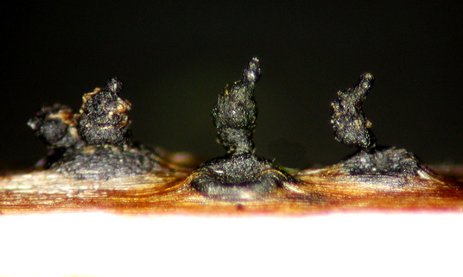 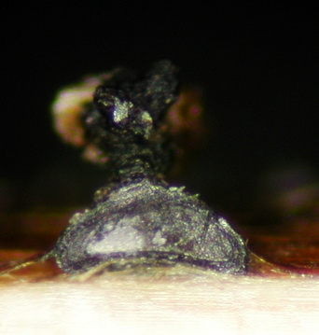 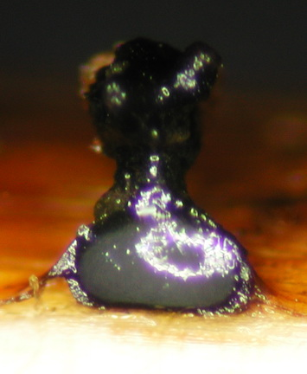 Ascomata scattered to gregarious, erumpent through the periderm, venters depressed to cupulate when dry, depressed spherical when moistened, ca 340 µm high x 500 µm diam, black, without visible stromatic tissue around, with stout ostiolar necks 340-420 µm high, central, cylindrical to swollen in mid part up to 250 µm diam, roughened, straight to contorted.
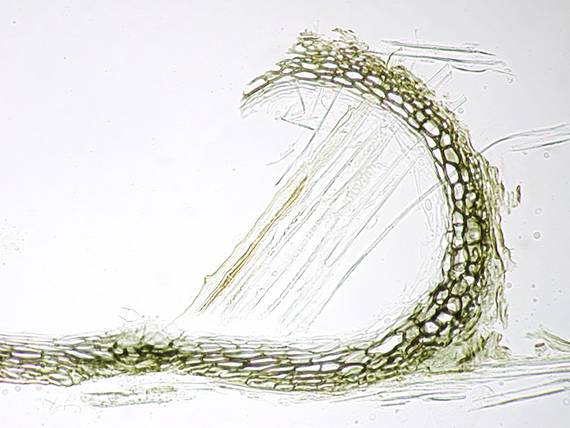Peridium 25-30 µm thick, 20 µm thick at base, pseudoparenchymatous, composed of 2-3 rows of dark brown, thick-walled, angular to flattened cells 12-15 (-27) µm long, surrounded by a thin concolorous layer made up of much smaller cells that can be seen as a stromatic layer (arrows).

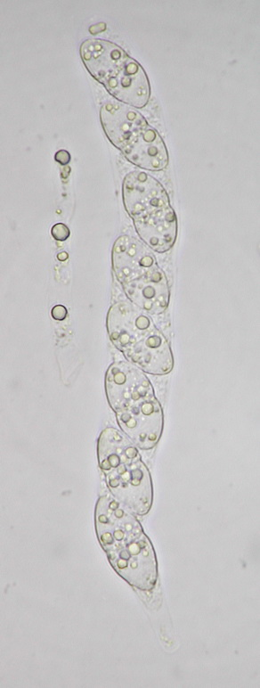 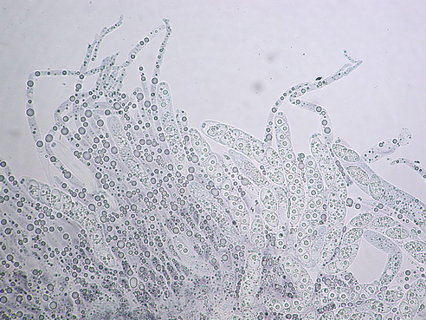 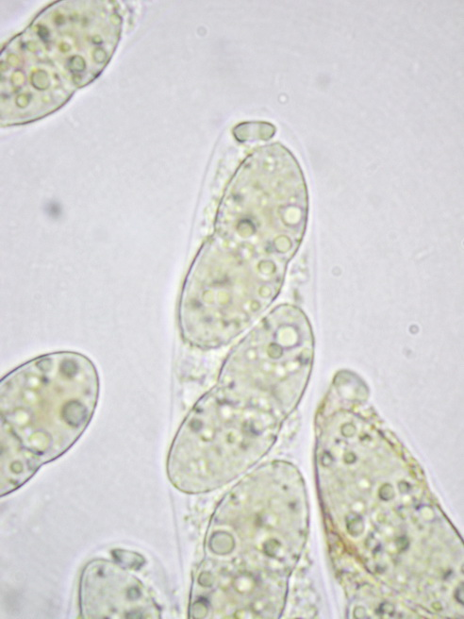 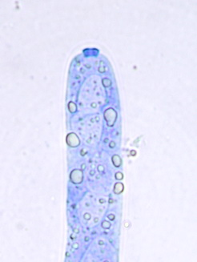 Asci unitunicate, 8-spored, 140-153 µm long x 14-16 µm broad, cylindric with a broadly rounded apex and a short stipe 15-24 µm long, often floating free in the centrum, with a massive, somewhat diamond-shaped, strongly refractive apical ring, J-, stained in dilute Waterman blue ink. Paraphyses copious, filiform, septate, 8-10 µm broad at base, tapering above, with sparse large oily guttules, longer than asci.
dilute IKI

Paraphyses in chlorazol black
water
Blue ink

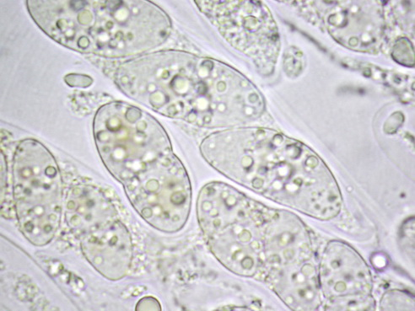 Ascospores 19-26 x 9-12 µm, obliquely uniseriate in the ascus, ellipsoid slightly inequilateral in side view, equally two-celled, constricted at the septum, with sparse oily guttules, hyaline, smooth, without visible appendages (free ascospores not seen).
dilute IKI

Comments: this material slightly deviates from the description given by Margaret Barr (1978) in longer asci and broader ascospores apparently lacking gelatinous material at ends.

