Notes on the ascomycete genus Stamnaria, obligate parasites and saprophytes on horsetails, Equisetum spp.
Originally arranged by Andrew Simon upon info shared by Erwin Gruber
Altered, respectively supplemented by Erwin Gruber, Styria, Austria.
gruberwin0529@gmail.com
@ flickr
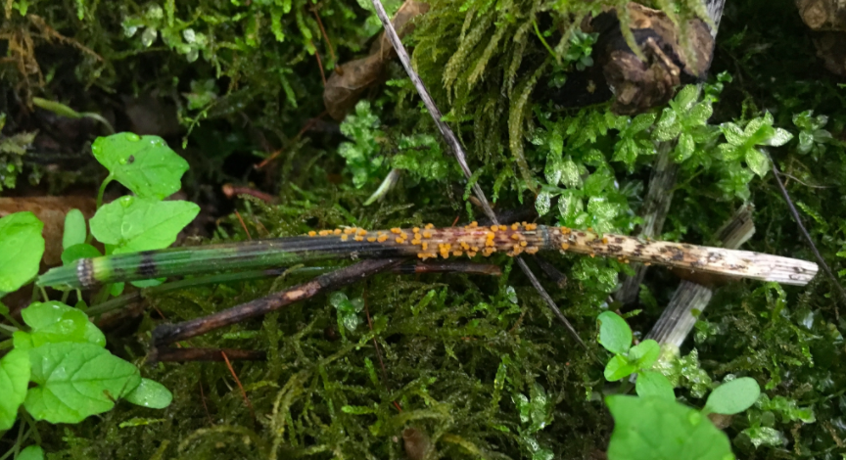
Stamnaria americana on Equisetum hyemale ssp. affine in Wisconsin, USA.
Photo taken and copyrights held by Alden Dirks, Ann Arbor, Michigan, USA.

Stamnaria is a genus of parasitic ascomycete fungi (Order: Leotiales, respectively Helotiales) that exhibits yellow to orange fruiting bodies, called apothecia, as well as spores, called conidia of the asexual Titaeospora type, on living as well as dead horsetails (Equisetum ssp.).
One group does grow apothecia on living shoots of Equisetum subgenus Hippochaete, as E. hyemale, E. laevigatum, E. ramosissimum, and occasional hybrids. These will frequently (perhaps not always?) follow an initial Titaeospora stage, bearing anastomosing, filamentous conidia.
Species’ of the other group do develop fruiting bodies from Titaeospora conidia bearing primordia on the year following infection, and may be found on dead material on the ground in late spring to summer. Asexual primordia (acervuli) were not proved for species’ inhabiting E. variegatum and E. sylvaticum by E. Gruber.

Most of the following species are documented in Europe and eastern North America. Some may be present in British Columbia, though they are not documented here to date. The genus Stamnaria appears to be rare in western North America—though it has possibly been overlooked.

Please share your observations with Erwin Gruber to help contribute to our knowledge of the diversity and distribution of the genus Stamnaria.

Equisetum arvense

Host to "Stamnaria mougeotii" (ined.) and, less commonly, S. persoonii (syn. S. equiseti), in Europe. The latter species has also been confirmed in association with E. arvense from the west coast of Greenland. Stamnaria was detected in association with E. arvense in an early mitotic (asexual) Titaeospora stage from southern Ontario in the late 19th century, but could not be determined to species.
Described characters of apothecia from Prince Edward Island do suggest presence of “S. mougeotii”, investigation of specimens is pending, see NBM F 07063, NBM F 07064.
Equisetum fluviatile

Host to Stamnaria persoonii (syn. S. equiseti) in Europe.
Stamnaria was also detected in association with E. fluviatile in an early mitotic (asexual) Titaeospora stage from southern Ontario in the late 19th century, but could not be determined to species. No fruitbodies have been verified from North America (by E. Gruber).

Equisetum hyemale

Host to Stamnaria americana and the closely related “S. laetissima” (Cesati) comb. ined. (s.lat.). Rare findings of the asexual stage on E. hyemale in western USA could not be identified to species. These reports are likely attributable to S. laetissima (s.lat.), vs S. americana, which is not known to occur here. On the other hand, S. laetissima has not yet been confirmed in association with E. hyemale outside of Europe.

Equisetum laevigatum

"Stamnaria laetissima" s. lat. has been found on living E. laevigatum, in Pullman, E Washington State, and Roseburg, Oregon (identified by E. Gruber as the nominative ssp. laetissima). Several specimens bearing asexual Titaeospora stage are also known on the same host plant from states in midwestern to western USA, which likely represent S. laetissima.

Equisetum ramosissimum

Host to S. laetissima (s.str.) in Europe and north Africa, quite likely as well in Asia.
This horsetail species is alien to America, but apparently naturalized in some regions. It is possible that it is host to another species of North American Stamnaria, in especial “S. laetissima” s. lat.

Equisetum sylvaticum

Stamnaria yugrana has solely been found on dead parts of E. sylvaticum, known from the Yugra region in western Siberia. This species was described in 2018.

Equisetum variegatum

Two unpublished species’, ”Stamnaria austriaca” ined. and "S. poeltii" ined., develop yellow to orange fruiting bodies on dead parts of E. variegatum in European Alps and elsewhere in Europe, as Scandinavia. These taxa may well have circumpolar range, as they are commonly overlooked.

Equisetum palustre, E. pratense, E. scirpoides, E. telmateia

Stamnaria has not yet been found in association with these species of horsetail (by E.G.) but may yet be discovered.

For more information and images, see the following reference online:

Horsetails infected by genus Stamnaria

Please note that most observations and images of horsetails have not yet been proved for presence of such ascomycetes.

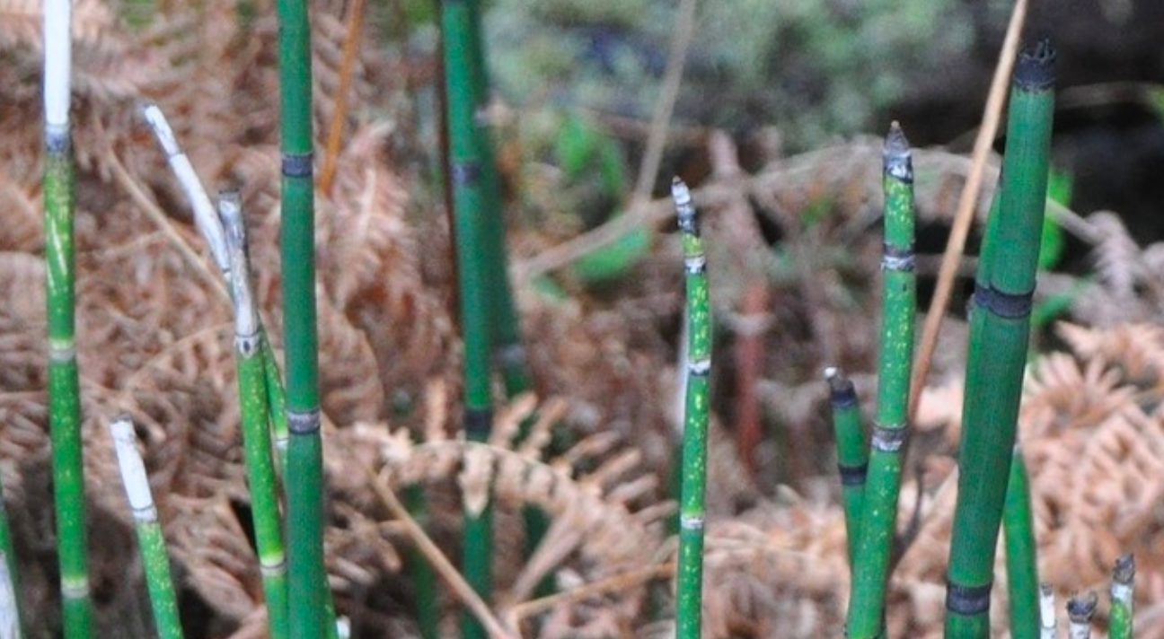
Frequent white spotting, usually at upper segments, indicate herbivory by arthropods; they do not suggest infection by Stamnaria, as there on Galiano Island, British Columbia, Canada.
Photo taken and copyrights held by Andrew Simon, Galiano Island, British Columbia, Canada.
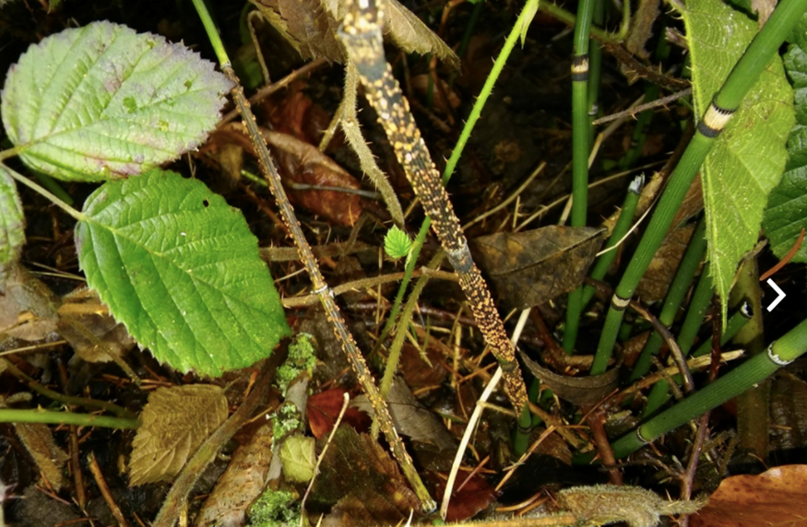
Stamnaria americana in Pfäffikon, Canton Schwyz, Switzerland.
Photo taken and copyrights held by Erwin Gruber, Frohnleiten, Styria, Austria.

