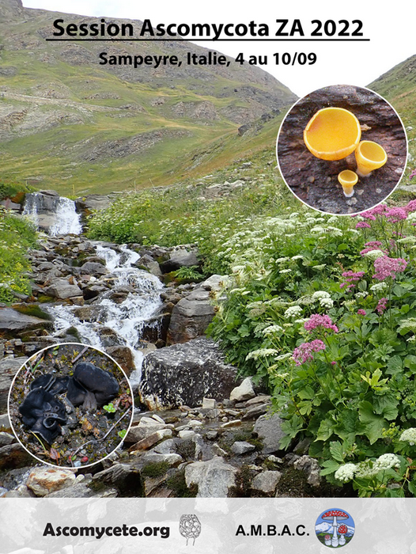
Alpine and Subalpine Ascomycota workshop 2022
From 4 to 10/09/2022 – Sampeyre- Italy
Organized with the cooperation of the Mycological Association of Ambac Cumino

Registration form to be returned before June, 25 2022
to promotion@ascomycete.org

The meeting will be held at the hotel “Torinetto” (***) in Sampeyre , via Calchesio, 7
Tel : 0039 0175 977181 - 977459 ; - www.torinetto.com –
Free WI FI provided

Field outings will take place from the Valle Varaita between Sampeyre (alt. 1000 m) and the Agnel pass (2800 m, French border) www.vallidelmonviso.it - www.unionevallevaraita.it
Collecting permissions will be provided in the protected areas.

To get to Sampeyre :
- By Plane -Turino Airport (Caselle) www.aeroportoditorino.it, Cuneo Levaldigi www.aeroporto.cuneo.it
- Aéroport de Nice Côte d’Azur (France) www.nice.aeroport.fr;

- By Train - Savigliano station : arrivals from Torino
- Cuneo station : arrivals from France
www.orario.trenitalia.com; www.ferroviedellostato.it;

- By Autobus - Cuneo-Saluzzo/Torino line Pontechianale-Valle Varaita stops at Sampeyre or Calchesio, near the hotel

-By car – The closest exit on A6 Torino-Savona is Marene
See the map hereunder .
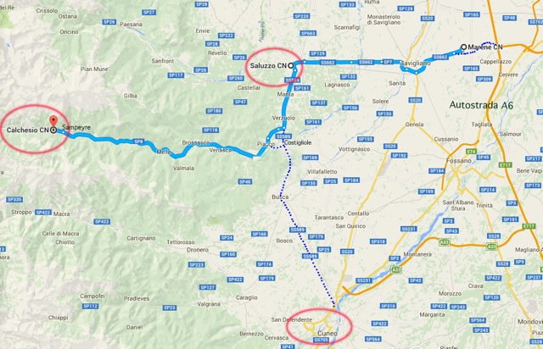
Registration form
Please return as soon as possible and before June, 25 , 2022
To promotion@ascomycete.org

Name :

Adress : ……………………………………………………………………………Country…………………..

Telephone : ……………………………… Email

Date of birth (for collecting authorizations) …..
Accompagnying person ………………………………………………………………………
I wish to share my double room with …………………………………………………………

Arrival time at the meeting on Sunday September,4 (in the afternoon) …………………...
Planned departure on Saturday, September 10 after breakfast

I will need space in the working room for
microscope binocular lense laptop else

An electrical plug compatible with Italian outlets will be necessary

Registration fees and deposit to be paid at registration time at Ascomycete.org

Deposit :50€ for hotel booking
Registration fees : Ascomycete.org members : 20€ Accompanying persons : 50€

Ascomycete.org member | 70€
Accompagnying person | 100€
 | TOTAL amount
Free cancellation will be possible until July, 31 2022

Full board at the hotel : including 6 nights in double room : 380€ per person, plus 15€ by night per single room . The balance of the stay will be paid at the hotel

Conference presentation suggested ………………
Payment
□ Bank transfer at « Crédit Agricole du Morbihan », BIC: AGRIFRPP860 — IBAN: FR76 1600 6091 1100 8257 4198 428
□ Chèque à l’ordre de Ascomycete.org (chez J.-P. Priou, 7 rue de Picardie, F-56200 La Gacilly) Mail : prioujpp@aol.com

Date : Signature

